

Systems Analysis and Design Project

Using ripple methodology and constructivist techniques

Dr. Iyad Al Bayouk

Al azhar University

**Abstract**

We are a team consisting of four people from Al-Azhar University. We visited one of the gyms to get acquainted with how the system works there. We interviewed the director of the sports club and some of the employees who manage the system and he asked them many questions that helped us understand the mechanism and content of the system they are working on in order for us to develop and improve his performance later.

**Case study**

Gym system Glossary

|  |  |  |  |
| --- | --- | --- | --- |
| Players (actor, business object)  Subscription type (business object)  Coach (actor, business object)  Sports type(business object | An example of a gym system, where the coach controls the system data. If the coach is a manager, he has an entry number and a user name through which he can control participants and determine the types of sports they play in this gym and determine the type of subscription and the duration of the subscription.  It determines the offers for players, and the types of subscription, whether it is annual, monthly or weekly, and it is able to easily know who has ended their subscription and who is still subscription |  |  |
|  |  |  |  |
|  |  |  |  |
|  |  |  |  |

**Case Study**

**Gym M.S** Business use case list

* **B**1 : Coach Sing in : Write his pass word and his user name

1. The manager coach logs in with his name and password
2. No coach can access the system, only them with administrators authority
3. As soon as the coach enters the system, a home page will appear for the coach with a message with the number of participating players whose subscription has ended, and below it a display button, and there is an entry button and an exit button
4. Once the coach presses the login button, the coach will go to the dashboard that contains the Add Player button, Delete Player button, Global search button, Multiple search button, Player Report button, Report on male subscribers button, “Report on female subscribers” button, and a button on current male subscribers And a report button on the current female subscribers and coach only button

* **B**2 : The coach adds new players to the system

1. When you click on the add player button The Coach can manually add the player's name, phone number, start date, end date, ID number and other personal information, such as gender and age.

* **B**3: The coach classifies the players on his own system

1. Depending on the player’s choice of his type of subscription, the coach enters the subscription period, whether it is annual, monthly or weekly
2. According to the player’s choice of the type of sport, the coach sets the sport for each player according to his choice, whether it is bodybuilding, fitness or kung fu.
3. According to the amount paid by the player, the coach enters the value paid and puts the remaining value due in his table for this player(manually)
4. the coach can move from one player’s record to another player’s record by choosing the previous record button or the Next record button, as the players are registered with numbers in ascending order
5. Each player registered with a number distinct from the other, and this number distinguishes his record if it was the first or last record
6. The coach can record notes about the players through the note box at the bottom

* **B**4: The coach Delete players from the system

1. When the coach clicks the delete player button, the coach can manually delete the players from the system.
2. When the player's subscription ends, the coach will search or directly access the player's record. If he does not renew his subscription, the coach will remove the player from the system.
3. The coach can also remove any player for other circumstances, such as choosing the player to leave the gym and recover the rest of his money for certain circumstances, where the coach can search for any player through his unique number and name
4. The coach can record notes about the players through the note box at the bottom

* **B**5: If we close the form, the system will save the changes and we will return to the dashboard.
* **B**6: The coach selects the multi-search button to search for players

1. If the coach chooses the multi-search button, a table will pop up for him to inquire about the players with their distinctive numbers, names, gender, date of joining, expiry date, type of sport, phone number, ID number and notes about the player that the coach previously recorded (through the player’s page).
2. The coach can search for any record of any player by the number of the distinguished player or the player name
3. The coach can also delete the records he wants to delete and delete the players themselves through the delete button

* **B**7: The coach selects the Player Report button for quick access to player records and quick modification

1. When choosing the Player Report button, a panel pops up containing a button to search for the player in his name and distinguished number. When the player chooses, he quickly adjusts his main data, such as the date of joining, type of sport, expiry date, phone number, ID number, or subscription type.
2. There is a print button through which the coach can convert this board into a pdf file to send to other coaches or to the player himself.

* **B**8: If the coach chooses the Report button about the male subscribers, an inquiry table will pop up for him with information about the current male subscribers

1. The table contains the male players, male players name, registration date, expiry date and phone number
2. The table contains a small panel showing the number of the male players currently registered in the table, and that's make the coach able to know the numbers easily
3. There is a button to print at the top of the schedule on the other side, which enables the coach to print the schedule, send it and share it to other coaches.

* **B**9: If the coach chooses the Report button about the female subscribers, an inquiry table will pop up for him with information about the current female subscribers

1. The table contains the female players number, female players name, registration date, expiry date and phone number
2. The table contains a small panel showing the number of female players currently registered in the table, and that's make the coach able to know the numbers easily
3. There is a button to print at the top of the schedule on the other side, which enables the coach to print the schedule, send it and share it to other coaches.

* **B**10: If the coach chooses the Global search button, an inquiry table will appear showing him all the players' information

1. The table shows the information of all male and female players. It shows gender, age, type of sport, type of subscription, start date, end date, offers. Is he/she a new player in this gym or he/she was previously a player of this gym?
2. The coach can easily see whether or not the subscription has ended, as the records of players whose subscriptions have expired are colored in red, while the records of players who have recently started their subscription are colored in green, and the records of players who have passed half the month or half of the subscription period, which is determined to be 30 days(To be determined by the coach in “coach only button”) are colored in orange

* **B**11: When the coach selects Report on male subscribers button an inquiry table will pop up for him with information about all the male players registered in the database in this gym since the beginning of the opening
* **B**12: When the coach selects Report on female subscribers button an inquiry table will pop up for him with information about all the female players registered in the database in this gym since the beginning of the opening
* **B**13: When the coach chooses “coach only button”, he can control the services provided by the gym

1. The coach can set the price situation
2. The coach is able to put the types of sports and training sessions available to it and the trainers available for it
3. The coach will be able to set and specify the number of days for one training session
4. The coach is able to manually specify the type of sport for each player, the training days for each player, and the offers that the players participate in

**Case study**

*Gym management system use case list*

**U**1: the Customer go to the gym web gate and sign up an account

**U**2: sign up an account: A Customer sign up account choosing (user name, password) to sing up in the Gym web page service

**U**3: The user page appears after the customer sign up that contains Information and allow the customer to subscribe to the service to become a member

**U**4: Subscription: A Customer create an Member account adding (name, age, gender, phone number, ID number) in network Gym page

**U**5: the Customer choose subscription type (yearly, monthly, weekly) then he choose the sport type (fitness, body building, kung fu)

**U**6: Membership: after the Customer finish adding his information he will pay the fee buy choosing paying method using paying gate after that he should register membership and become member

**U**7: members control panel: Each member have a control panel through which he can renew his subscription, make a report, unsubscribe, or change the type of subscription line or the type of sport

**U**8: Information: The coach gets a full report on all new members registered day by day

**U**9: manager login: Write his pass word and his user name

**U**10: The manager adds new Members to the system

**U**11: The manager classifies the Members on his own system

**U**12: The manager Delete Members from the system

**U**13: If we close the form, the system will save the changes and we will return to the dashboard

**U**14: If the manager chooses the Report button about the current male Members, an inquiry table will pop up for him with information about the current male Members

**U**15: If the manager chooses the Report button about the current female Members, an inquiry table will pop up for him with information about the current female Members

**U**16: If the manager chooses the Global search button, an inquiry table will appear showing him all the Members' information

**U**17: When the manager chooses “manager only button”, he can control the services provided by the gym

**U**18: Member service is the responsibility of employees who receive member complaints and questions

**U**19: The manager selects the new member’s button to reveal the most recent registered members

**Case study**

Gym use case survey

Any Customer can take a look at the gym web page and sign up an account if he want(U1) he will choose username and password to sing up in the Gym web page service (U2) an user page appears after the customer sign up an account that contains a brief about the institution, the latest offers, a button to subscribe to the service, and the administration number for communication and inquiries (U3) then the Customer create an Member account adding (name, age, gender, phone number, ID number) in the Gym network (U4) the Customer choose subscription type (yearly, monthly, weekly) then he choose the sport type (fitness, body building, kung fu) (U5)

the customer pay the fee buy choosing paying method using paying gate after that, congratulations, you are now a registered member)U6)

now you have your control panel that will help you to renew of end your membership or if u want a refund or change the sport (U7) the manager will receive a report with all the information (U8) the manager will sing in (U9) and add new members (U10) , classifies members from the system (U11) or delate members (U12) the manager can search for both mail and female members and (14+15) open their reports(U15) by choosing global search the report will pop on the screen so he can get all the information he want and The amount paid and the amount due, the start date and how much time is left for the membership to expire (U16) and he can control the services provided by the gym(U17)

Member service is involved in the cycle by helping anyone who needs help with the system (U18)

The manager selects the new members button it shows him an inquiry table containing the latest new members during the last week (U19)

• Customer. A person who visit the Gym website and create a free account to see what is realy going on and to watch the latest news and offers

• Member. A Customer who has presented his name, address & Credit Card details at one of our branches, each member has his own password and Username that allow him to enter the system and renew his membership or end it or refund

• Member service. An employee who answers the questions of the customers and the members.

• Manager. He can search for all the details he wants to know about the members and change what he wants and he have all the authorities

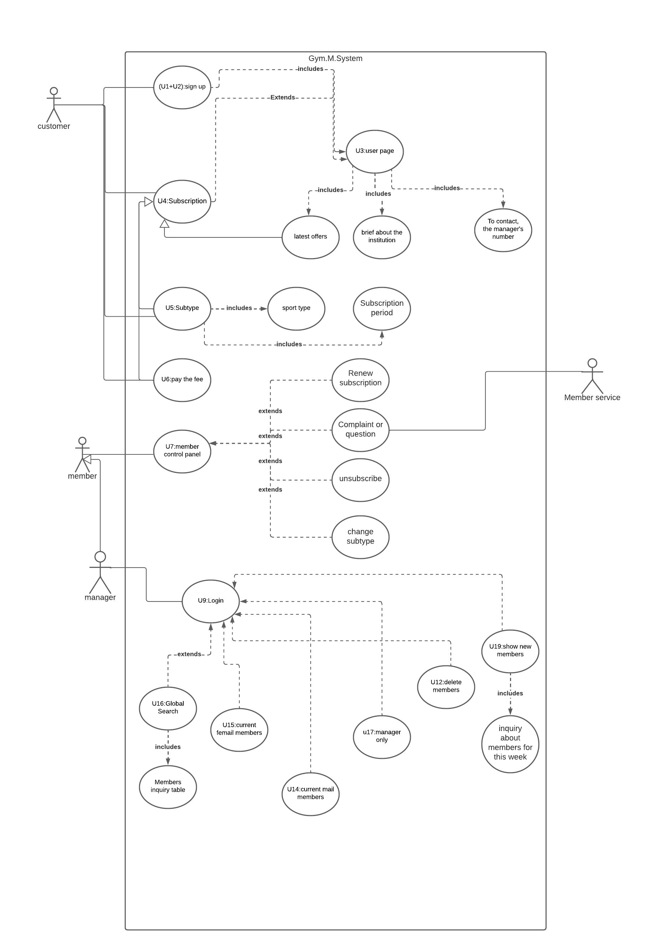

**The final use case diagram for the Gym M.S**

**Case study**

Gym use case survey

* U1+2: sign up: the customer sign up into the system.(includes U3)
* U3: user page: the user page appears .(extends U4, include latest offers, brief about the institution and To contact, the manager's number )
* U4: subscription: the customer make an account.( specializes U5,U6, latest offers)
* U5: subtype: .( specializes U4, include sport type and Subscription period)
* U6: pay the fee: the customer pay the fee by the pay gate he chose.( specializes U4 )
* U7: member control panel:
* Each member have a control panel through which he can renew his subscription, make a report, unsubscribe, or change the type of subscription line or the type of sport
* Member service receives questions, inquiries and complaints from members

(Extend Renew subscription, Complaint or question, unsubscribe, and change subtype)

* U9: login: manager enter his user name and password. (extends U12,U14, U15,U16,U17,U19)
* U16: global search: the manager can search for member’s files. (include members inquiry table)
* U19: show new members: the manager can look at the new members in the gym. (include inquiry about members for this week)

Details Format

**U**1: **sign up. (Includes U2. U3.)**

**Preconditions: None.**

1. **The Customer go to the gym web gate and sign up an account**
2. **The customer must choose a username**
3. **The customer must choose a password**
4. **The user page appears that contains a brief about the Enterprise, the latest offers, a button to subscribe to the service, and the Manager number for contact and questions**
5. **The latest offers specialized U4**

**Post conditions: None.**

**Non-Functional Requirements**

**r1**. **Displays a specialized advertisement on the user web page**

**U**4: **Subscription. (Abstract. Specialized by latest offers. U5. U6.)**

**Preconditions: None.**

1. **A Customer create an Member account by adding (name, age, gender, phone number, ID number) in network Gym page**
2. **the Customer choose subscription type (yearly, monthly, weekly**)
3. **The Customer choose subscription type (fitness, body building, kung Fu)**

**Post conditions: None.**

**U**5: **Subtype. (Specializes U4)**

**Preconditions: None.**

1. **Include sport type**
2. **Include subscription period**

**Post conditions: None**

**U**6: **Membership. (Specializes U4)**

**Preconditions: after the Customer finish adding his information.**

1. **The customer will choose paying method**
2. **The customer will pay the fee using paying gate**

**Post conditions: the Customer** **should register membership and become member**

**Non-Functional Requirements**

**r1**. **An email to confirm the membership registration process**

**U**7: **members control panel. (Extended by** renew sub, reports, unsub, change subtype**)**

**Preconditions: the Customer** **should register membership and become member**

1. **Each member have a control panel through which he can renew his subscription, make a report, unsubscribe, or change the type of subscription line or the type of sport**
2. **Member service receives questions, inquiries and complaints from members**

**Post conditions: The data is automatically recorded in the company's database that the manager can access through the system**

**Non-Functional Requirements**

**r1**. **An e-mail message goes to the member in case he faces a problem to contact him by phone and solve it by the member service**

**U**9: **manager login. (Extended by U12.U14.U15.U16.U17.U19.Show new members.)**

**Preconditions: None.**

**1. Manager enters his user name**

**2. Manager enters his password**

**3. The manager is a specialized of the member, as he has powers that enable him to do everything that the member does manually**

**4. The manager selects the new member’s button to reveal the most recent registered members**

**Non-Functional Requirements**

**r1**. **If the manager closed the form, the system will save the changes and we will return to the dashboard**

**User interface sketch**

